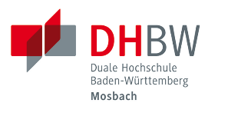
Duale Hochschule
Baden-Württemberg
Mosbach, Campus Bad Mergentheim
Schloss 2
97980 Bad Mergentheim

Title

Bachelor Thesis for the Bachelor of Arts Examination at DHBW Mosbach

Major/minor: Business Administration – International Business

Course: Course

Family name, first name: Family name, first name

Date of birth: 01/01/….

Place of birth: Anytown

Family name, first name of the
academic examiner/advisor: Advisor

Name and address of the
workplace training provider: Company

Submission date: 09/03/20...

The content of the present work must not be accessible as a whole or in parts to persons beyond the examination and the evaluation process as long as no contrary approval of the workplace training provider is available.

